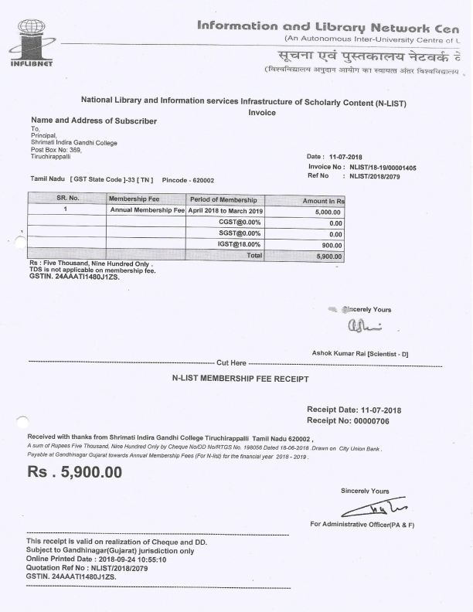

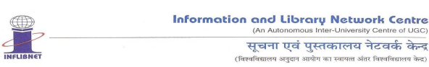

**National Library and Information services Infrastructure of Scholarly Content (N-LIST)**

**Quotation**

**Name and Address of Subscriber**

To,

Principal,

Shrimati Indira Gandhi College

Post Box No: 369,

Tiruchirappalli **Date : 2020-02-06 13:35:02(Website)**

**Tamil Nadu [ GST State Code ]-33 [ TN ] Pincode - 620002 GSTIN : 33AAATT6266H1ZD**

**Ref No : INF/N-LIST/2020/2079**

**SR. No. Membership Fee Period of Membership Amount In Rs**

**1 Annual Membership Fee April 2020 to March 2021 5000.00**

**CGST@0.00% 000.00**

**SGST@0.00% 000.00**

**IGST@18.00% 900.00**

**Total 5900.00**

**Rs : Five Thousand, Nine Hundred point Zero Zero Only .**

**TDS is not applicable on membership fee.**

**GSTIN. 24AAATI1480J1ZS**

You are requested to kindly send your order along with the annual membership fee.

1. Mode of Payment: Annual Membership fee shall be paid through.

(a)Demand Draft in favour of “INFLIBNET-NLIST Account” payable at Gandhinagar or

(b)RTGS/NEFT fund transfer to INFLIBNET-NLIST Account as per the details given below:

Beneficiary Name: INFLIBNET - NLIST Account

Bank Name: State Bank of India

Branch: Infocity, Gandhinagar

Bank Address: Unit GWGF/2, Ground Floor, Infocity, Gandhinagar, Gujarat

Bank Account No: 31104082931

IFSC Code: SBIN0012700

MICR Code: 380002151

Important Note:

• In case of RTGS/NEFT payment, kindly send the payment details viz UTR No., date of payment to INFLIBNET Centre through email at paymentinfo@inflibnet.ac.in or letter to INFLIBNET Centre Gandhinagar

**• Membership Fee once paid is not refundable.**

2. Payment should be made within 15 days of recipt of quotation.

**Sincerely Yours**



**Ashok Kumar Rai**

**Scientist - E**

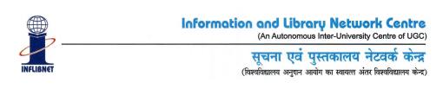**National Library and Information Services Infrastructure of Scholarly Content (N-LIST)**

**Invoice**

Ref No.: INF/N-LIST/2021/2079 Date: 2021-09-15 Invoice No.: NLIST/21-22/1856

College GST No.: 33AAATT6266H1ZD

College GST State Code: TN [33] **Name and Address of Subscriber**

To

The Principal

Shrimati Indira Gandhi College

Post Box No: 369,

Tiruchirappalli

Tamil Nadu - 620002

**SR. No. Membership Fee Period of Membership Amount In Rs 1 N-LIST Annual Membership Fee April 2021 to March 2022 5,000.00** CGST@0.00% 0.00

SGST@0.00% 0.00

IGST@18.00% 900.00

**Total 5,900.00**

**Rupees Five Thousand Nine Hundred Only**

GSTIN: 24AAATI1480J1ZS

TDS is not applicable on annual membership fee.

Sincerely Yours



Ashok Kumar Rai

Scientist-E(CS)

------------------------------------------------------------------- Cut Here --------------------------------------------------------------------------------- **N-LIST MEMBERSHIP FEE RECEIPT**

Receipt Date: 2021-09-15 Receipt No: 53267

**Received with thanks from Shrimati Indira Gandhi College, Tiruchirappalli, Tamil Nadu**

A sum of Rupees Five Thousand Nine Hundred Only by Cheque No/DD No/RTGS No. CIUBH21258011690

Dated 2021-09-15 drawn on CITY UNION BANK LIMITED Payable at Gandhinagar Gujarat towards N-LIST

Annual Membership Fee for the financial year 2021-22.

**Rs. 5900**

****Sincerely Yours

For Administrative Officer(Finance)

This receipt is valid on realization of Cheque and DD.

Subject to Gandhinagar(Gujarat) jurisdiction only

Online Printed Date : 2022-01-10 05:51:07

INFLIBNET Ref No : INF/N-LIST/2021/2079

**GSTIN. 24AAATI1480J1ZS.**